Sport day - Primary section
On 29th January, Don Bosco School, Borivali West, celebrated its Sports Day for the Primary Section with great enthusiasm and energy. The event was graced by our Chief Guest, Rev. Fr. Jewin Johnson Mastan DBS is the Vice President of Dominic Savio , Andheri, whose presence encouraged and motivated the young participants.
A variety of exciting events were organised for the students, including different running races such as 80 m and 100 m, along with fun and skill-based activities like Book Balancing, Mini Ball Collectors, Hurdle Race, Relay Race, and Tug of War for Standards 3 and 4. The children participated with great sportsmanship, joy, and competitive spirit.
At the end of the event, Blue House emerged as the overall champion, while Red House secured the position of second runner-up.
Category-wise Champions:
- In the Girls’ category (Std. 1 & 2), Aashvi Sapaliga II D CBSE won the championship.
- In the Boys’ category (Std. 1 & 2), Zayn D’souza II C CBSE won the championship.
- In the Boys’ category (Std. 3 & 4), Nivaan Kadam III C CBSE won the championship.
- In the Girls’ category (Std. 3 & 4), Pariha Karadkar IV B SSC won the championship.
Adding to the excitement of the day, a 100 m race was also organised for parents in both the men’s and women’s categories, which was thoroughly enjoyed by all and brought great cheer and laughter to the audience.
The Sports Day concluded with a message highlighting the importance of sports in our lives. Sports teach children discipline, teamwork, confidence, and perseverance, helping them grow not only physically but also mentally and emotionally. The day was a grand success, leaving everyone with happy memories and renewed enthusiasm.

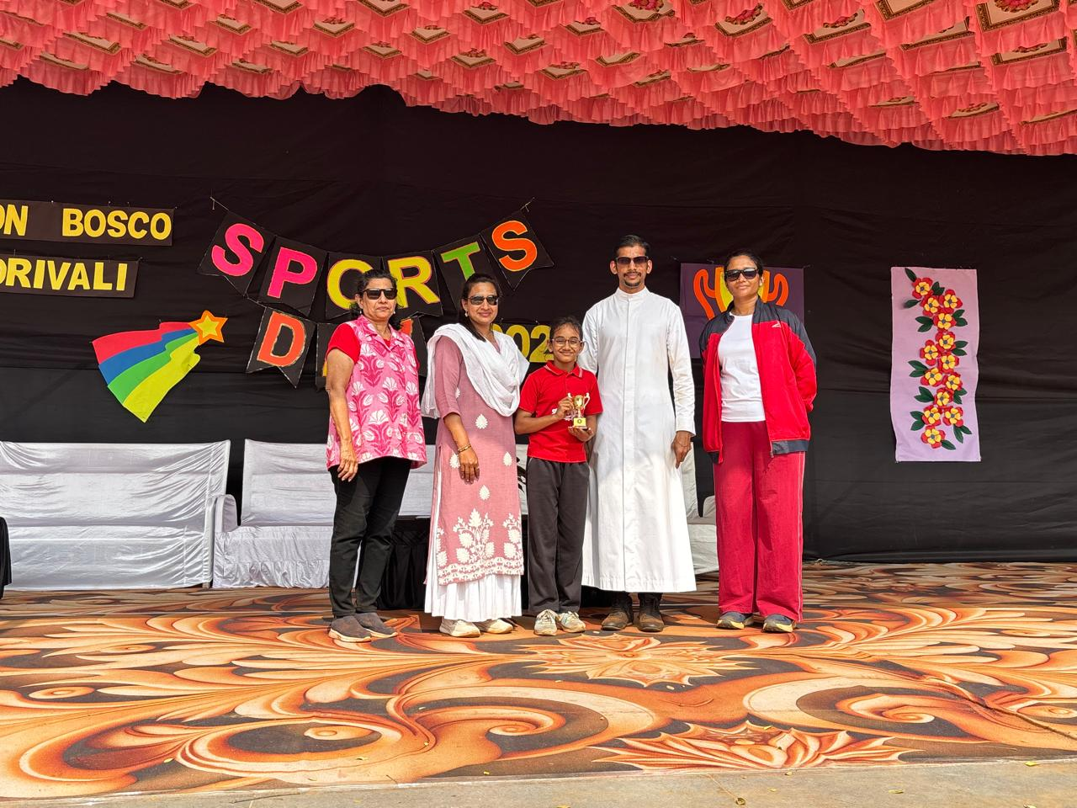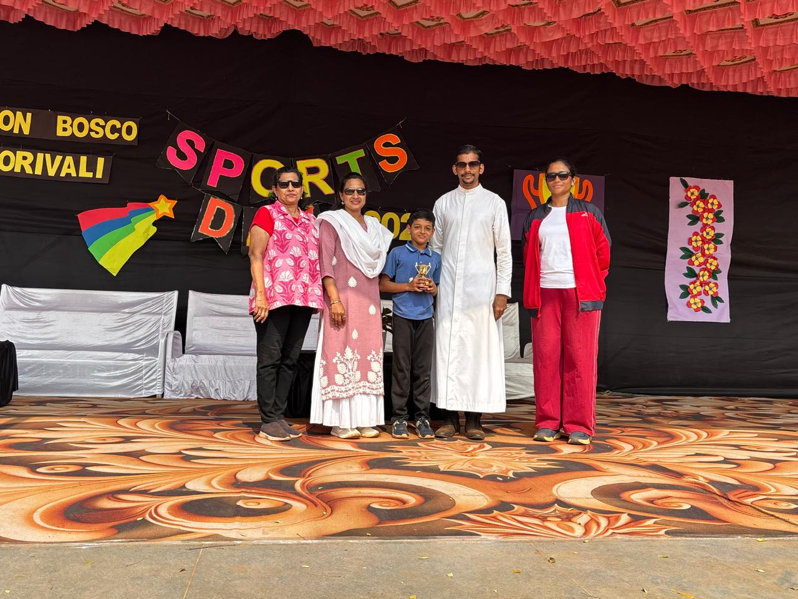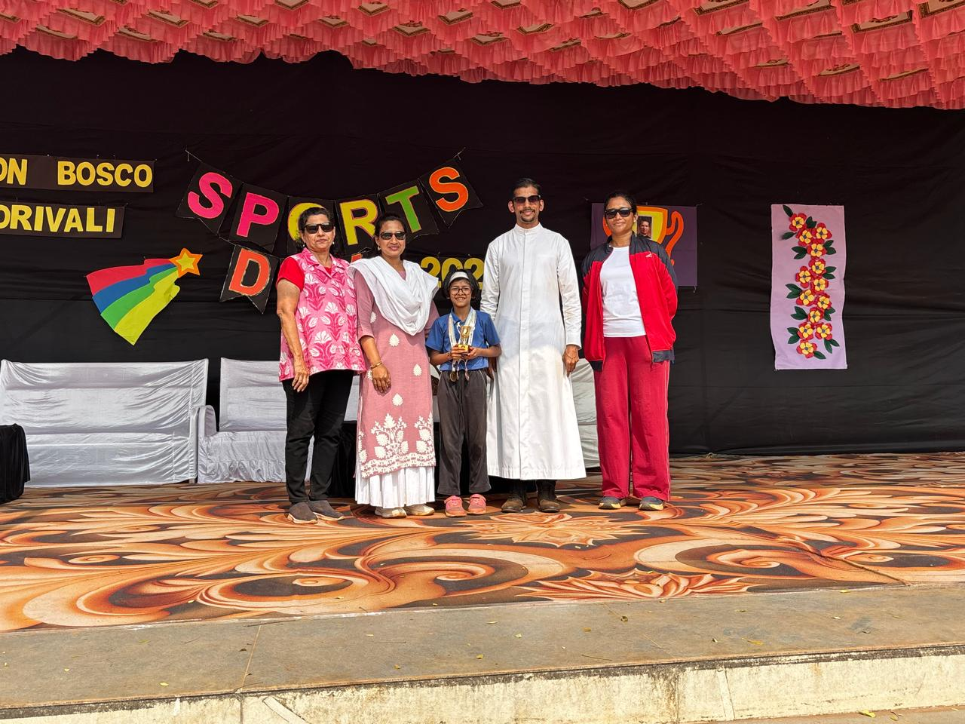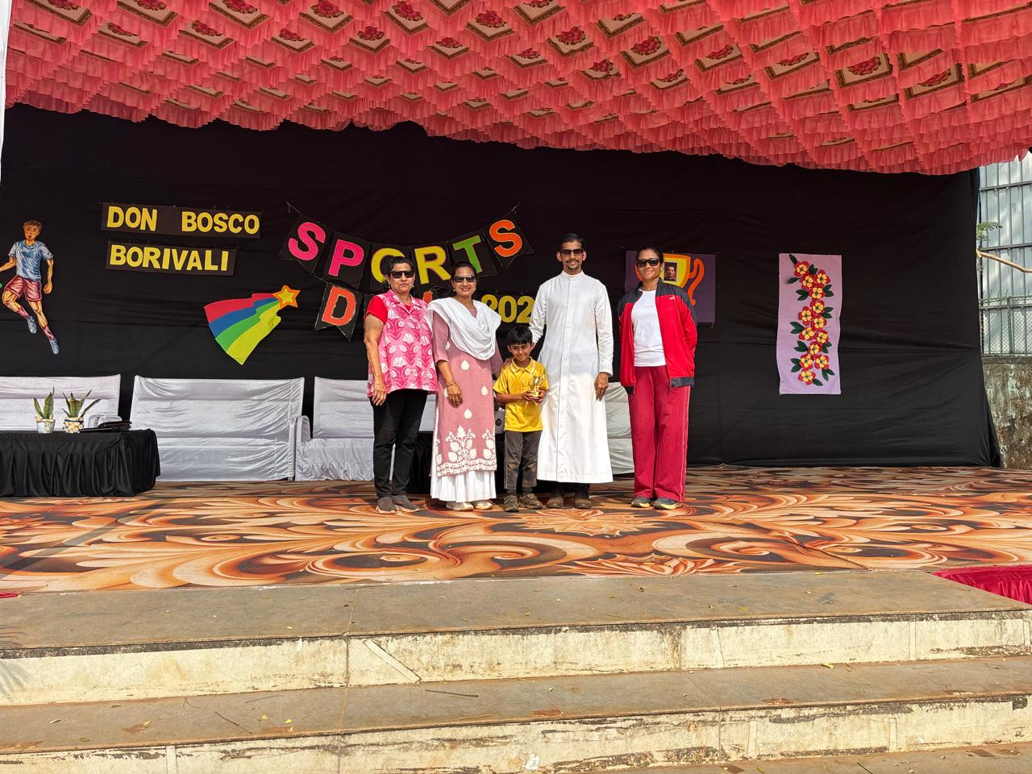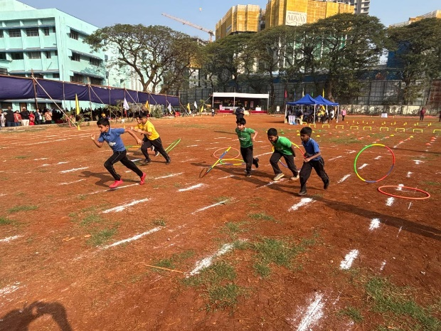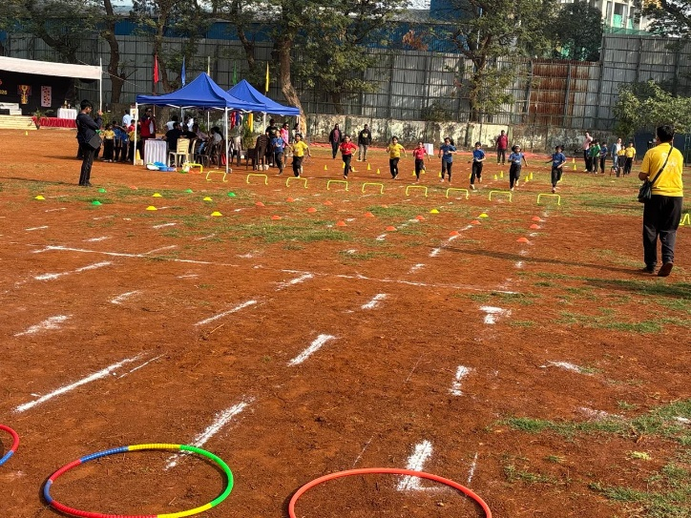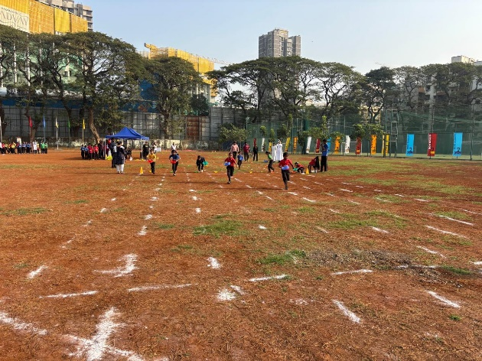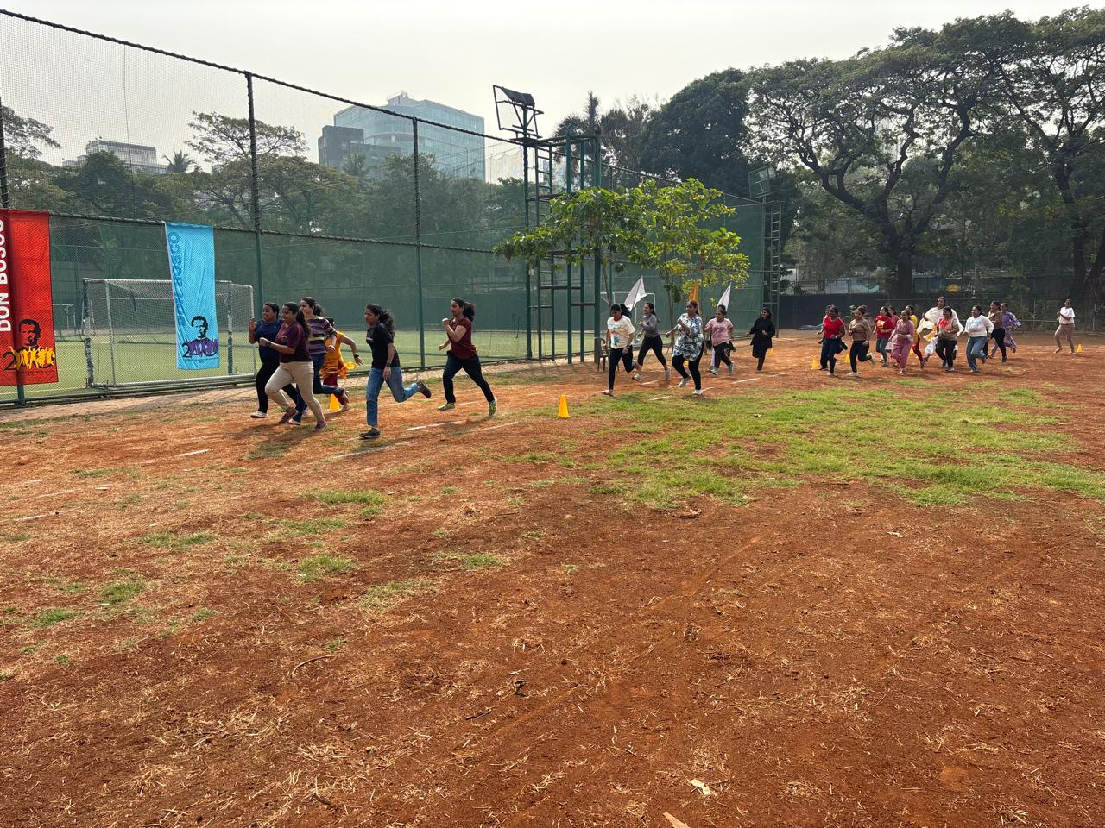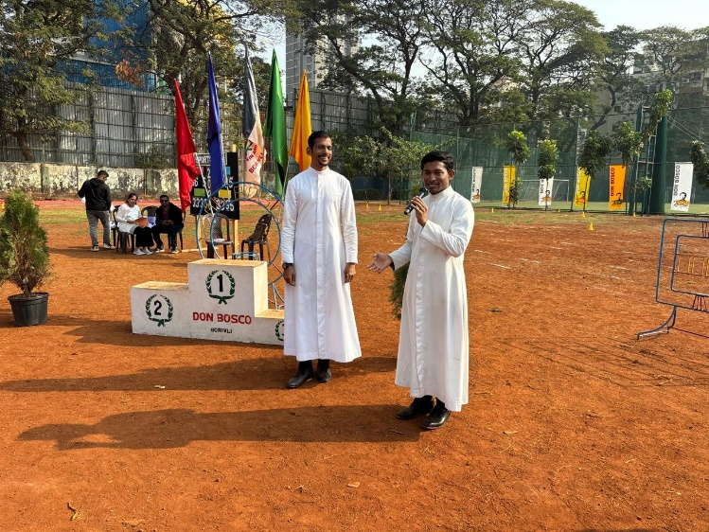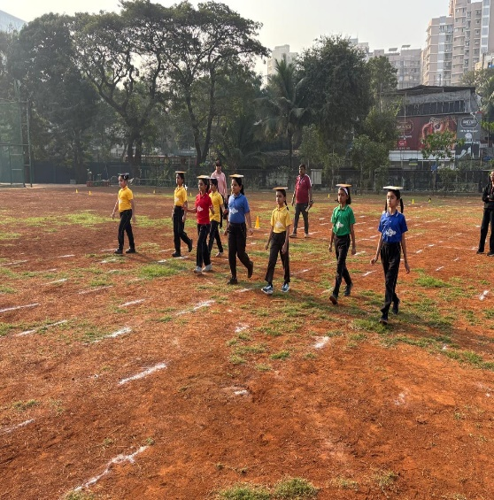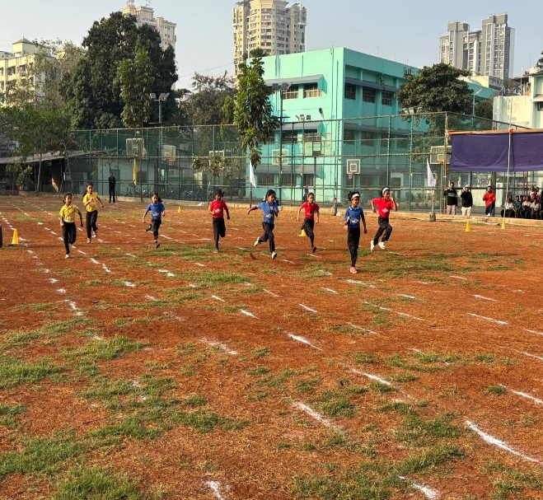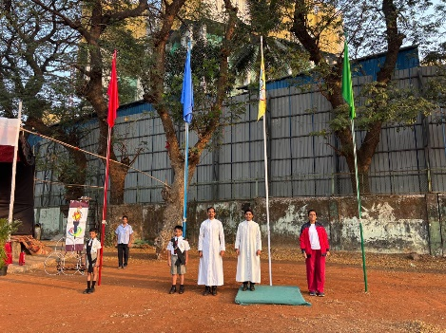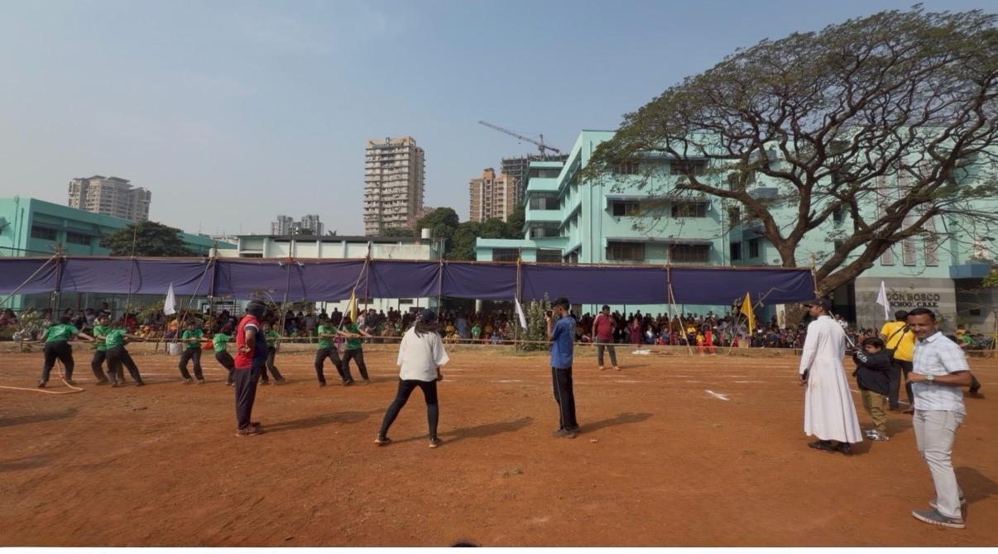
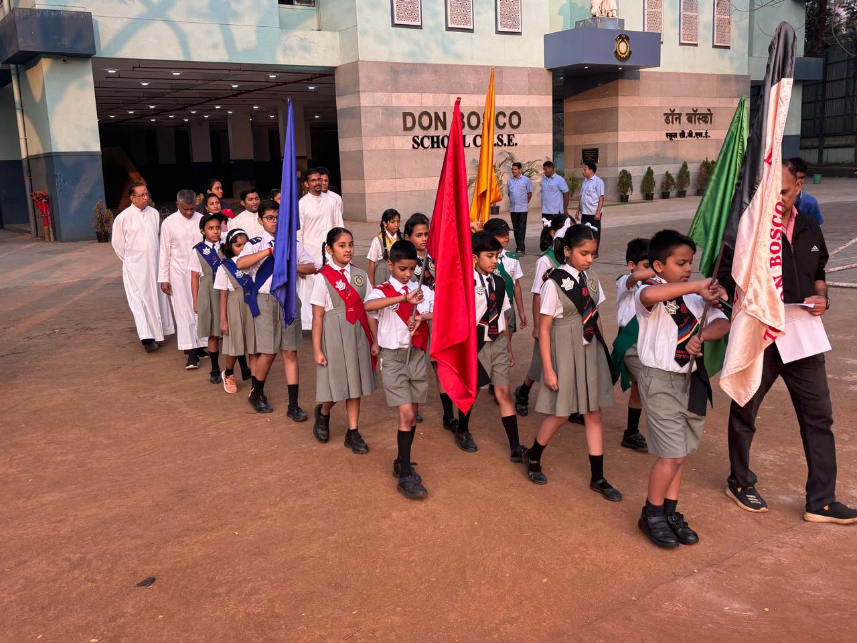
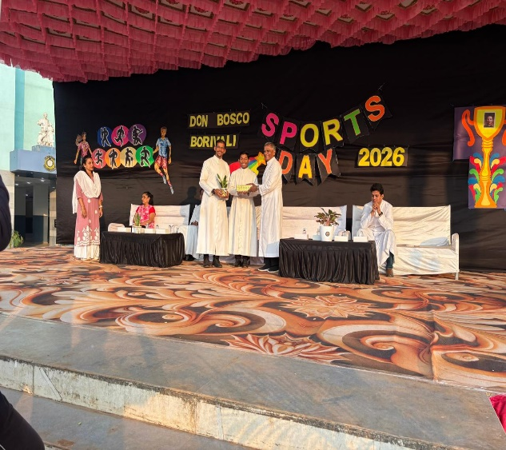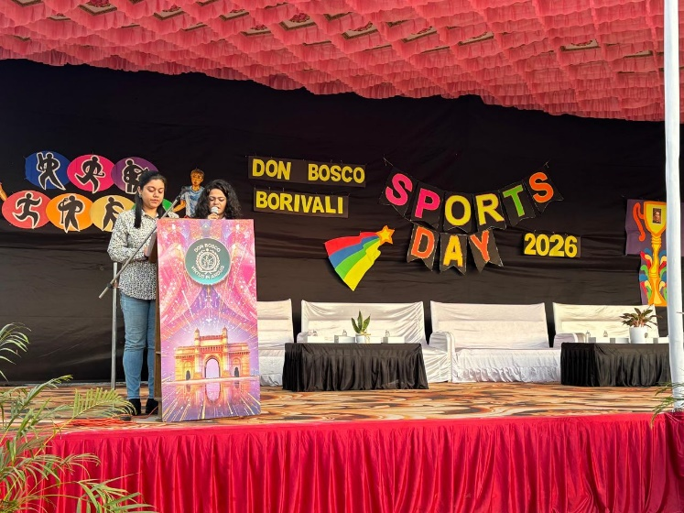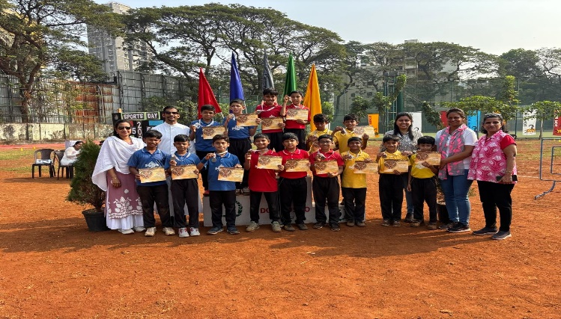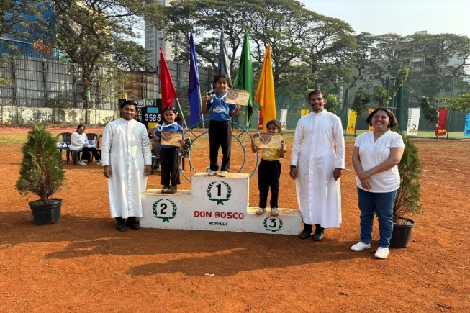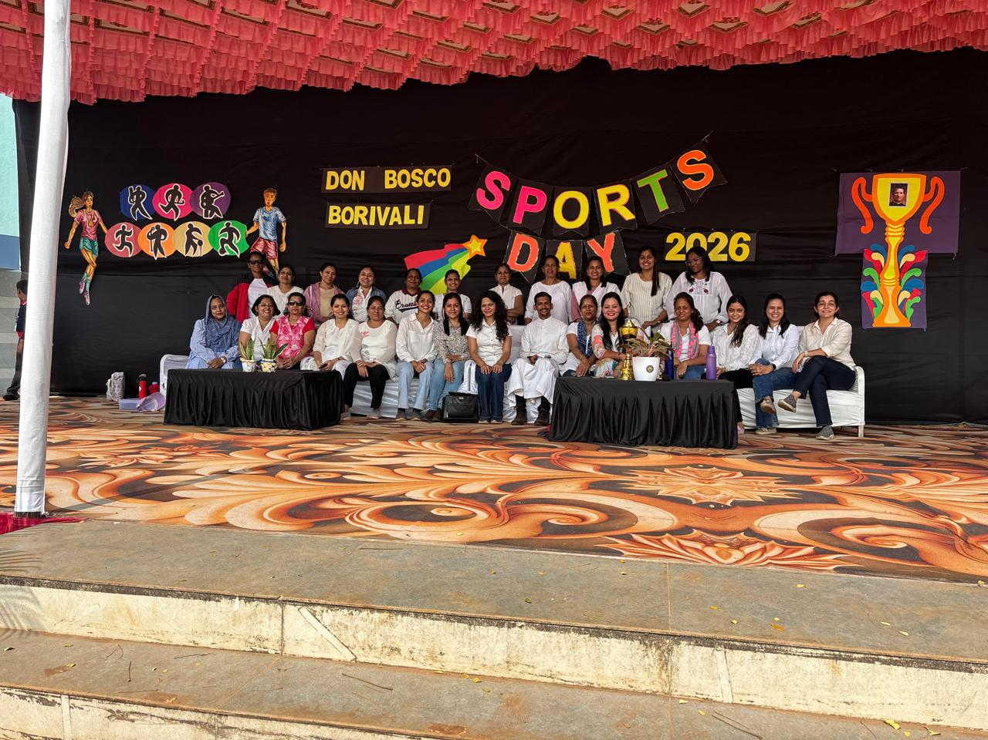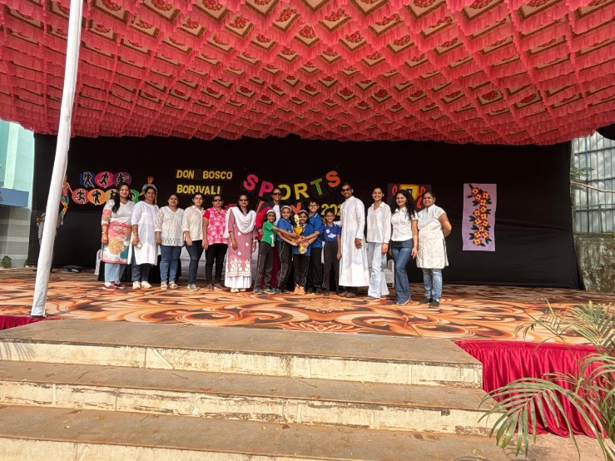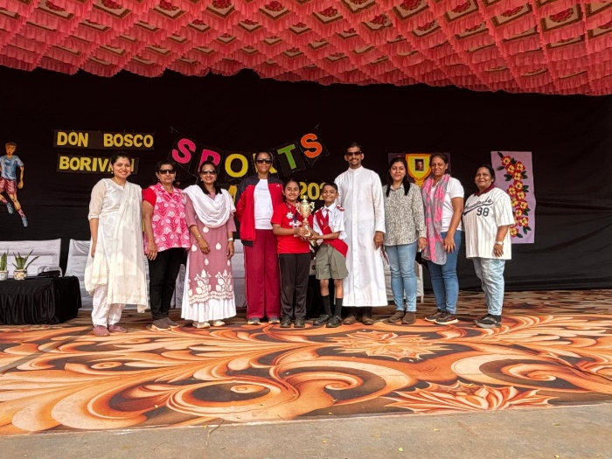

Bottom of Form

